Auto Billing Mall Shopping Cart 8051

Shopping is easy but waiting on a bill counter after shopping is too booring and tedious task. Huge amount of rush plus plus cashier preparing the bill with barcode scanner is too time consuming and results in long ques. So here we have made an innovative project which will be placed in the shopping trolley itself.
The system consist of of a RFID reader which is controlled by 8051 microcontroller. So whenever the shopper puts any product in trolley it is been detected by the rfid module and it is displayed on LCD along with the price of the product. As the shopper adds more things it is detected by the module and the price according to that increases. In case if customer changes his/her mind and doesn’t want any product added in the trolley he can remove it and the price added will be deducted automatically. At the end of shopping the shopper will press the button which when pressed adds all the product along with there price and gives the total bill to be paid. At exit For verification the the shopkeeper can verify the shopping with the help of master card.
Hence this system is suitable for use in places such as supermarkets, where it can help in reducing man power and in creating a better shopping experience for its customers.
Block Diagram:
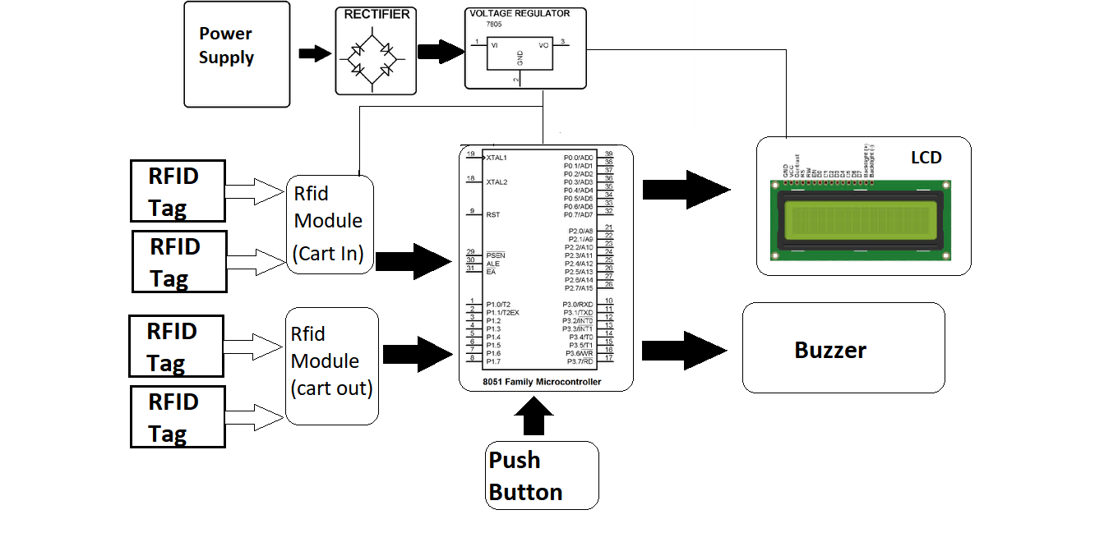

Hardware Specifications

- AT89S52 (8051 Microcontroller)

- RFID Module & Cards

- LCD’s

- Crystal Oscillator

- Resistors

- Capacitors

- Transistors

- Cables & Connectors

- Diodes

- PCB

- LED’s

- Transformer/Adapter

- Push Button

- Switch – Buy Switches & Buttons Online

Software Specifications
- Keil compiler

- MC Programming Language: C

